Blue print of 1 std. ( Total 60 marks)
1.Fill in the blanks -5 marks.
2.Name the following - 5 marks
3. Put (✔) or (x) - 6 marks
4. Circle the correct word. -8 marks
5. Answer the following -8 marks
6. Match the following -6 marks
7.Circle the picture -4 marks
8.Draw and colour -4 marks
9. Name the picture -4 marks
10. Label the picture - 4 marks
11. Match the objects -6 marks

Class:I Second Terminal Examination 2019
Social science QUESTION BANK .

- Fill in the blanks
1. The national flag of Kingdom of Bahrain is _______________and ____________ in colour.
2. Parents always make us _______________.
3. I __________ in the school playground.
4. I live with my ______________ in my house.
5. The people of Bahrain are called ________________.
6. Zallaq is a famous _________________.
7. At school we learn to ________________ and ______________.
8. Parents of our parents are called __________________.
9.I live with my ________________in my house.
10.Parents give us good _____________and________________.
11.I live in a _____________________.
12.The Bahrain is known as the ______________of gulf.
13.Father and mother together are called ___________________.

II Name the following.

- Clothes we wear in winter.
_________________
2.Two dresses used by girls .
_____________ , _________________
3.The currency of Kingdom of Bahrain is.
_________________.
4.Two things we use when it rains.
_______________ ,________________.
5.Two dresses used by boys.
_________________, _______________
6.The language of the kingdom of Bahrain.
________________.
7.The capital of the kingdom of Bahrain .
___________________.
III.Circle the correct answer.
- We run and play in the ( playground)/classroom).
- We eat out meals in the (dining/ living) room.
- At school our( teacher/ principal ) help with our lesson.
- We must keep our home ( dirty / clean ).
- ( Woollen/ cotton ) clothes keep us cool .
- We (eat/ work ) in the lunch break.
- We should be (on time / late) for school.
- We must keep our classroom ( clean / dirty ).
- We get story books from the ( classroom / library ).
10. ( Woollen / cotton ) clothes keep us cool.
11.We run and play in the ( classroom/playground).
12.( flat / hut ) is a home in building.
13.My ( family/friend ) live in my house.
14.We wear (different / same ) kinds of clothes.
15.We must keep our home( dirty/clean.)
16. We get wool from ( cow /sheep).
17.We wear( pants/ socks) in our feet.

IV.Put (✓ )for True and (X )For wrong answers.
1.All houses are built with bricks.( )
2.We wear clothes to cover our bodies.( ).
3.We play in the kitchen.( )
4.We wear raincoat when it is hot.( )
5.We bathe in the bathroom.( )
6.We sleep in the bedroom .( )
7.A house keep us safe from heat and cold.( )
8.We use umbrella when it rains.( )
9.We play in the kitchen. ( )
V.Match the following.(pg no:4 and 17)
VI.Circle the picture ( page no 22 )
VII.Answer the following.
1.What is a small family?
2.Why do we wear clothes?
3.Name five rooms in a house.
4. Who is the head of your family?
VIII.Draw and colour the National Flag of Bahrain.

IX. Label the picture using helpbox

Mother | Sister | Father | Brother
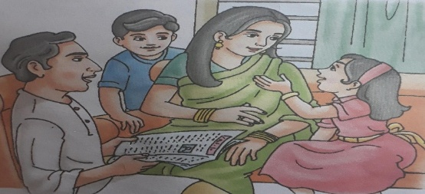

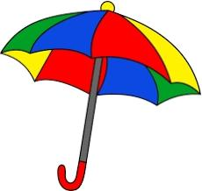
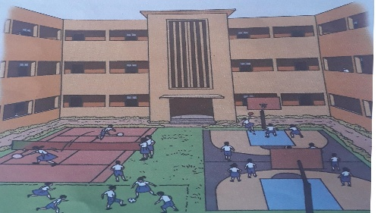
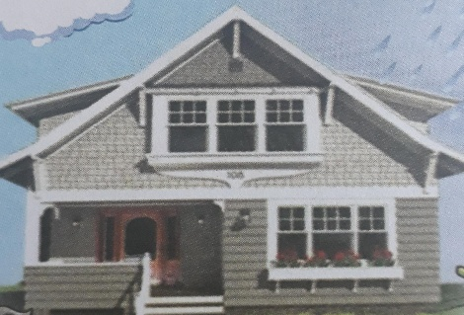
X. Name the picture.

1.________________ 2.________________ 3.___________

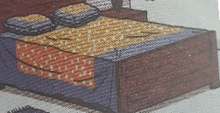
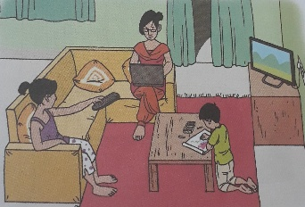
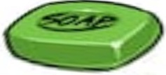
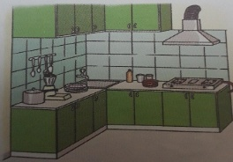
XI. Match the object in their correct room
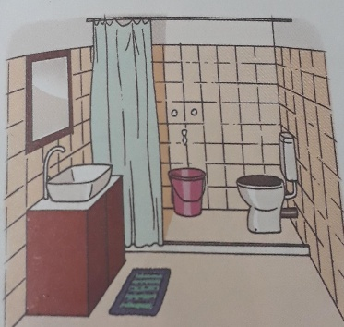
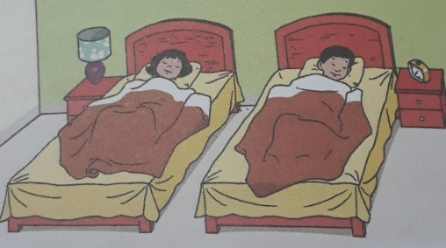
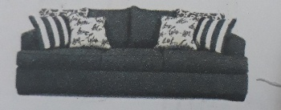
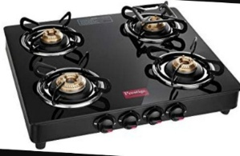

3
4.

